### /Preview/

### Smartphone adoption by low-literate users in India

A contextual interview involving 110 users spread across Mumbai (City), Wai (Town), and Menavali (Rural) was conducted by the students of Interaction Design 2015-17 batch in Maharashtra, India.

Year: August, 2015

Time Period: 2 weeks

Number of researchers: 14 design students

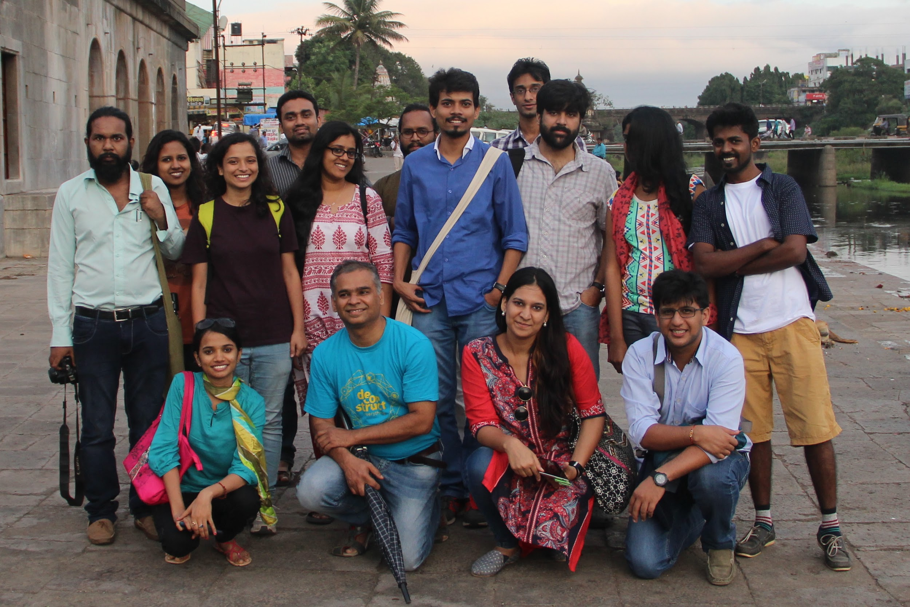

Location: urban, suburban and rural areas in the states of Maharashtra and Madhya Pradesh in India (Locations were chosen to make sure the research happened in both urban and rural areas. )

Education: Less than or equal to 12th standard

Occupation: shop owner, rickshaw and truck driver, tailor, cattle owner, homemaker, peon, etcetera.

Semi-structured interviews were conducted first, followed by analysis of the interview which was later transcribed. Then affinity mapping of the statements yielded findings

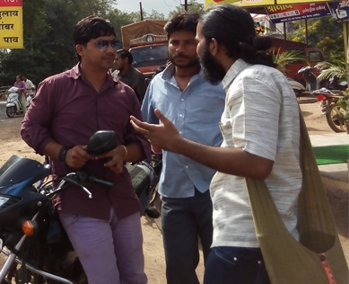

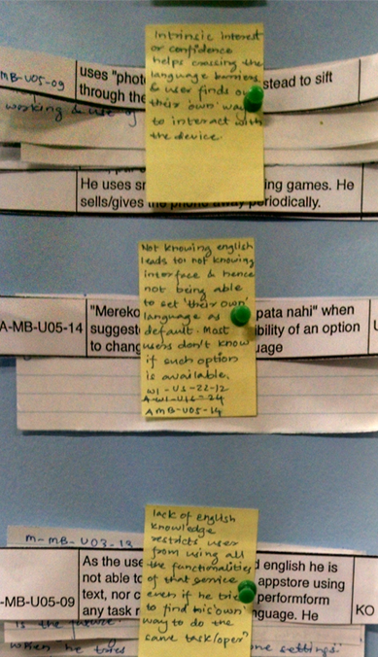

Key Findings: observations in purchase decision making patterns, social influences, usage deterrents, comparisons between physical and digital usage, usage of PINs and passwords, E-commerce, Risk assessment and mitigation, the concept of privacy, designated app usage among others.

The entire study and its findings have been consolidated into three papers, which have been submitted to CHI 2016 conference and can be found in [Media and Entertainment](http://homepages.iitb.ac.in/~saloni/acads/UserStudies/documents/MediaEntertainment.pdf), [Usable Security](http://homepages.iitb.ac.in/~saloni/acads/UserStudies/documents/UsableSecurity.pdf), and [Whatsapp](http://homepages.iitb.ac.in/~saloni/acads/UserStudies/documents/Whatsapp.pdf).